Money
Your best bet is just to withdraw some money from the ATMs directly in the airport. There are also some exchange offices.

Taxi
There are many taxis at the hotel. The guy with the walkie talkie in his hand running around at the beginning of the taxi queue is in charge and will select a cab for you. The price is about 50TL.

Phrase
Ben Double Tree Hilton hotele gitmek istiyorum (Fuarın yanında, aşağıdaki haritada görebilirsiniz)
I want to go to Double Tree Hilton hotel. If they don’t know the hotel, show the text in parentheses.

Bus
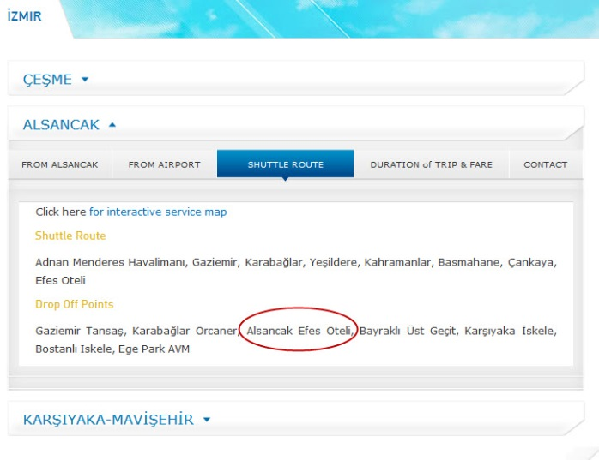
From airport you should take the Havas bus for Alsancak (about 10 TL). Your drop off point is Efes/Swiss Hotel and in the attachments you can find it highlighted. From there to the Double Tree Hilton hotel is around 10 min walk. I also included a map showing the route from Efes Hotel (red point) to your hotel.

Walk from bus stop
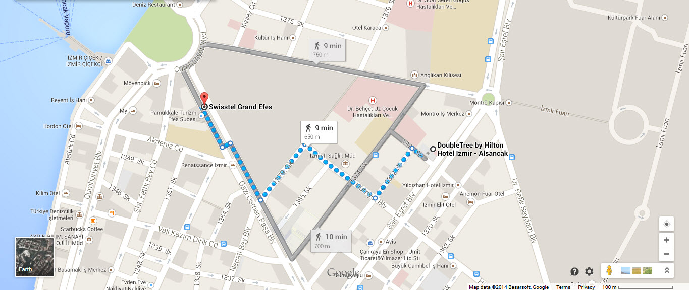

Phrases
Havaş durağı nerede?
Where is the bus stop?
Double Tree Hilton Hoteli hangi tarafta?
Which direction is the Double Tree Hilton hotel?

Train
For the train, you need to take İzban (to Aliağa direction)
Get out at Hilal or Halkapınar station.
Take the metro to Çankaya (circled in map below) and walk from there to hotel.
You need to get a ticket (but we are not sure about the ticket station at the airport). This may cost about 10TL in total but it may be an adventure. One ticket e.g.: for three rides is good for bus, metro, and train alike.

Phrases
Izban nerede?
Where is the train?
Bilet nereden alabilirim?
Where can I buy the ticket?
Metro nerede acaba?
Where is the metro?
